EmpowerWeb Install
EmpowerWeb is installed as a .NET Framework application Web Site under IIS on a network server.

IIS Web Sites, Applications and Virtual Directories

The following is an overview of the steps are taken to add the EmpowerWeb as a web service on IIS.

Install IIS on a server.

Install EmpowerWeb Software in a Physical Folder on the Server Running IIS
EmpowerWeb is an ASP.NET application using the .NET Framework v4.xxxx or above. It is installed via an .msi file into a physical folder. The physical folder is subsequently assigned to a Web Site.

Create EmpowerWeb as a new Web Site in IIS.
A Web Site a location connected to the Internet, or intranet, that displays one or more pages to a user. Websites may be a simple collection of one or more related pages or an application.
EmpowerWeb is a Web Site which runs under IIS as an ASP.NET application.

Create an EmpowerWeb Application Pool in IIS.
An IIS Application Pool handles the processing of all users of a web site.
An Application Pool should be limited to one Web Site to prevent a failure in one web site from taking down another web site under the IIS server.

Create a Virtual Directory in IIS.
A Virtual Directory is associated with a Web Site and is used to point to a physical folder on disk.
EmpowerWeb uses a Virtual Directory in IIS to store a file that instructs EmpowerWeb how to connect to your database.

Create a SQL Server Login Account for EmpowerWeb to Connect to your Empower Database
You need to grant permission to the Empower database via a built-in user since
Users may not be logged into Windows via Active Directory when using the web site.

Download the Latest Version of EmpowerWeb
Use the EmpowerSupport application to download the latest version of the EmpowerNet applications. EmpowerSupport downloads an EmpowerWin .msi file, an EmpowerWeb.msi file and an EmpowerService .msi file (if licensed), into the Updates folder you specified in EmpowerSupport. The default Updates folder is
C:\Program Files(x86)\EmpowerNET\2.0\EmpowerSupport\Updates\n.n.xxx

each time you download a new release of EmpowerNET.

Install the Latest Version of EmpowerWeb on the Website Hosting Server
Signed onto the server hosting IIS, navigate to the EmpowerSupport Updates folder.
Run the EmpowerWeb.MSI file.
This downloads the EmpowerWeb application to the folder C:\Program Files (x86)\EmpowerNET\2.0\EmpowerWeb on your IIS server.

Create a Folder and Copy the Database Connection Config File
Migrate to the folder

C:\Program Files (x86) \EmpowerNET\2.0\EmpowerWeb on your IIS server.
In this folder create a new sub folder: _config.
In a later step of the installation, we will create a Virtual Directory in IIS to point to this folder.

Copy the Empower.config file from EmpowerWin
Migrate to the folder on the server hosting EmpowerSupport
C:\Program Files (x86)\EmpowerNet\2.0\EmpowerSupport
And copy the empower.config file and paste it into the newly created folder on the Web Service server:
C:\Program Files(x86)…\ _config
Empower.config is a text file that contains information on how to connect to your Empower production database that you configured in EmpowerSupport previously.

Add Domain\Server$ User to MS SQL Server Logins
The EmpowerWeb web site needs a user to connect to the Empower database.
In the Empower.config file you just copied to the IIS server the database connection string uses Integrated Security to connect to the database.
Since users may be accessing EmpowerWeb from outside your Domain, and are therefore not validated via Active Directory, IIS will use a built-in Microsoft Account : Domain\Server$ (where Domain is the name of your domain and Server is the name of the server hosting IIS) as the user for SQL Server to validate when connecting to the Empower database.
To give the Domain\Server$ user access to the Empower database run SQL Server Management Studio and connect to the SQL service under which the Empower database is running.
Click on the Security folder, then right click on the Logins folder and select Add User.
Add a User, Domain\Server$, where Domain is your domain name and Server is the name of the server that IIS is running on.
In the Add User response window fill in the information on each tab as follows:
Tab | Property | Value
General | Name | Domain\Server$
Server Roles | Server Roles | Check Public
User Mapping | Users Mapped to This Login | Check and highlight the EmpowerWin Database
 | Database Role Membership For | Check dbowner  Check Public
Securables | Securables | Use the Search button and select the name of the server running MS SQL Server from the pop-up window
Status |  | Grant and Enabled are checked by default. Change them if not checked.

Edit Server Roles on the IIS Server
On the server running IIS run Server Manager.
Select Roles and Features
Verify that:
Web Server IIS Installed role is installed,
Web Server Installed
Application Development
ASP.NET 4.x

are all checked. If not check them to install these Roles.

Create the EmpowerWeb Web Site in IIS

Run IIS,
Right click on Sites in the Navigation Panel and select Add Website, Type EmpowerWeb, or the name you want users to use when connecting to EmpowerWeb, such as ABCPayroll if your company name is ABC. We use EmpowerWeb in this example as the IIS Web Site name.
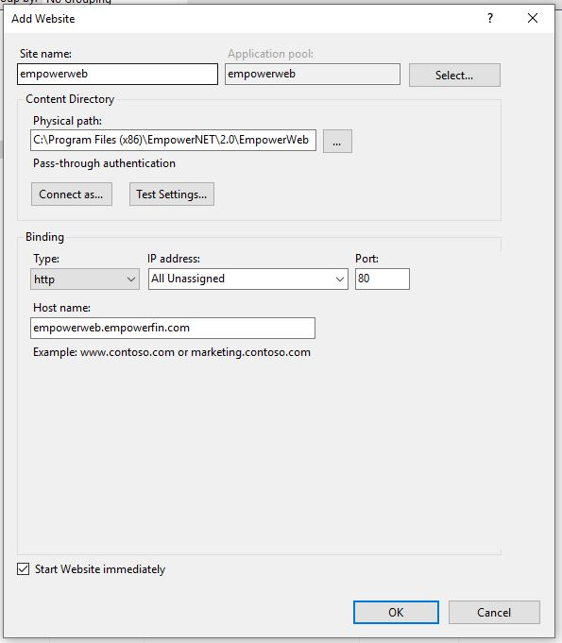

The Application Pool column defaults to the name of the website (EmpowerWeb in this example). Leave this as is. When the website is created the Application Pool is automatically created by IIS.
For the Physical path use the default path (shown above in the picture). This is the path used by the EmpowerWeb.msi file you ran in a previous step.
Leave the binding columns as defaulted.
The Host Name is what users will type in a browser URL to access the Web Site.
You will set this up in your networks DNS. We suggest using: sitename. Domain, where sitename is the Site name of the Add website window and domain is the name of your Domain. In this example you would enter empowerweb.empowerfin.com since we named the web site empowerweb and our domain name is empoerfin.com.

Create the Config Virtual Directory under the EmpowerWeb Application in IIS

Right click on the Web Site, then click on add a virtual directory.
Set the Alias to config
set the physical path to the _config folder created earlier.
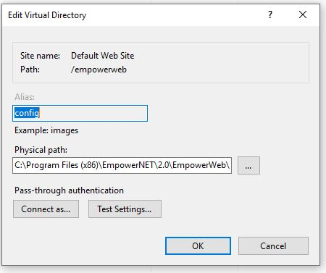

Refresh the IIS Server and Test the Web Site

For the above changes in IIS to become effective you need to Start and Stop the IIS Server.
To test the Web Site, open a web browser on the server and type in the URL:
<Web site alias>.<full domain name>
For example, empowerweb.empowerfin.com
A login page should appear.

Create the DNS mapping to your web site

Run the DNS manager on your network.
Create an Alias for the sitename.Domain that maps to the IP address of the IIS server.

Creating EmpowerWeb on IIS Summary
Web Site:
Name: empowerweb,
Root Directory: C:\Program Files (x86)\EmpowerNET\2.0\EmpowerWeb
Application Pool :
Name: empowerweb,
with .NET 4xxxx, integrated

Virtual Directory:
Associated with the Web Site
Name: config
Physical Path: C:\Program Files (x86)\EmpowerNET\2.0\EmpowerWeb\_config

SQL Server User
Give permission for Domain\Server$ user to access the database using SQL Server Management Studio

DNS
Create a DNS Alias for your website

Trouble Shooting
